Web Forms
How to complete the form

When completing the form, there are certain elements that are common in every section. This page covers these basic functionalities and highlights the sections that are common for all applications.
The form provides on screen information, as well as warning messages, specific for the application form or field currently being entered. Please read this on screen information and if you require further assistance please consult the content related to the specific key action application request. This can be viewed from the Index page: Web Application Forms Guidelines.
Important: Do not use multiple tabs in browser
When filling in the required information in the Web Application Form do not use multiple tabs or open several browser windows for your application. This will cause problems with the auto save functionality of the form and result in lost data in your application.
- Language Selection
- Mandatory Sections and Fields
- Navigation through/within application sections
- Menu button
- Underlined Links
- Auto Saving & Draft
- Help and Guidelines
Language Selection
The default language of the screens is set to English. To change it, click on the language icon at the right hand of your screen and select the required language in the populated window.
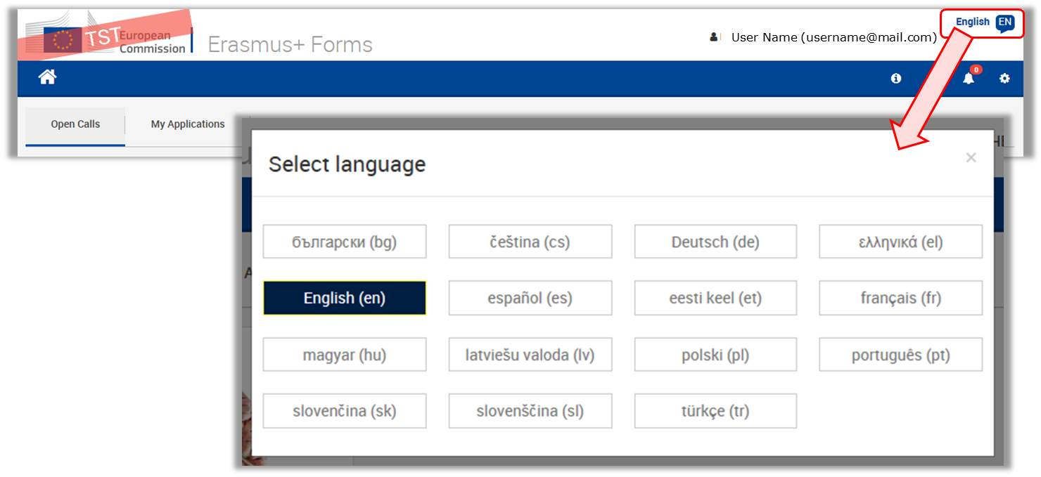

Mandatory Sections and Fields
Mandatory sections are marked with a red exclamation mark indicating missing information or that not all rules for filling in the application form were respected.
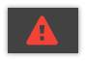
Most individual fields which are mandatory are marked with red to make it easy to identify and fix issues.
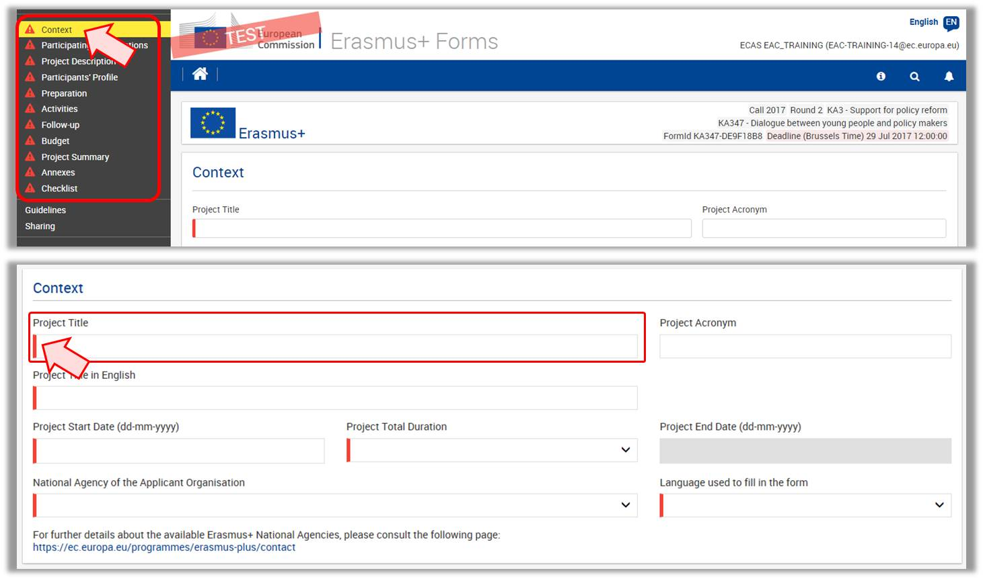
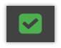
Once all mandatory fields and validation rules in a section are met, sections will be marked with a green check.
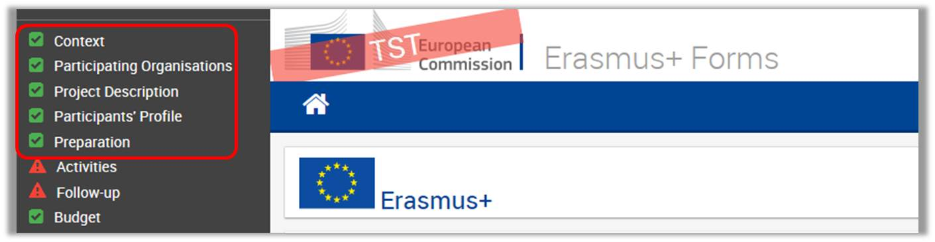
Individual mandatory fields completed are marked green.
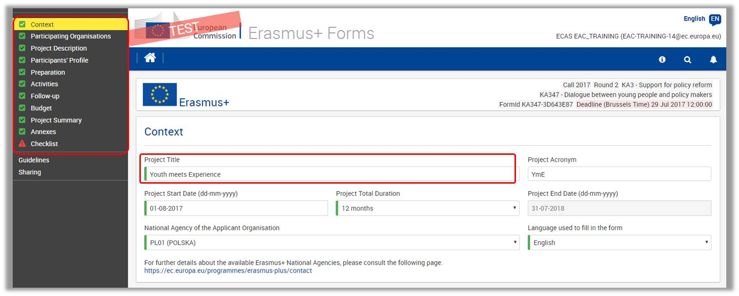

Navigation through/within application sections
Within the Web Application Form you have several options to easily navigate between sections or sub-sections.
In a variety of screens you have a top menu, which can be used to navigate back and forth within a project section.
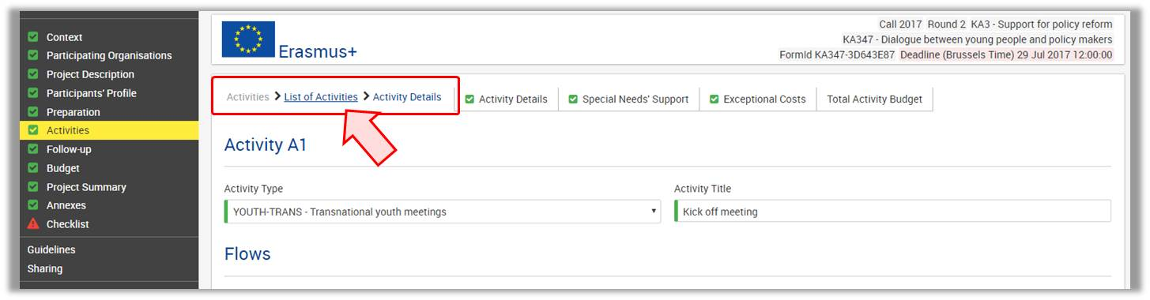
Within a project section you may have tabs available. Those can also be clicked on to quickly access specific information.
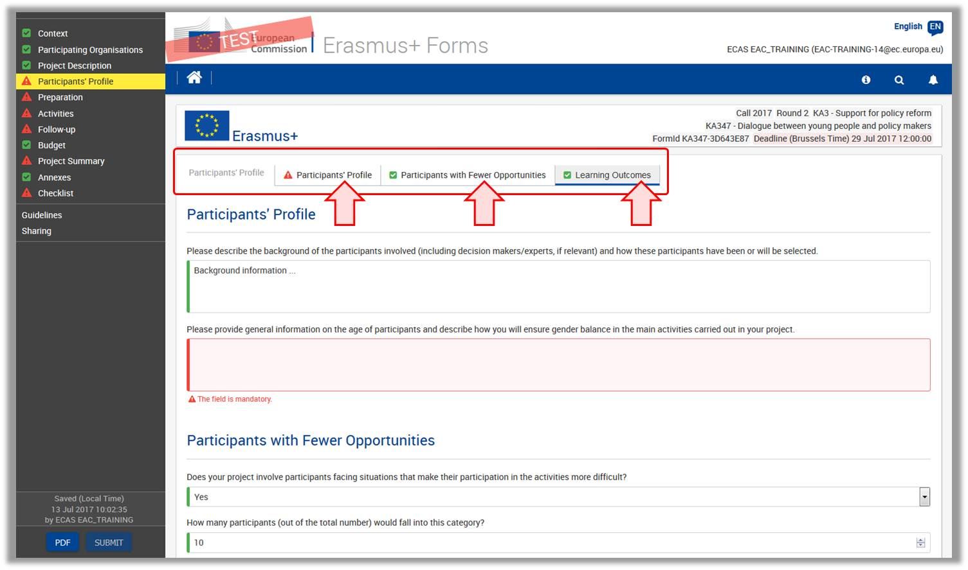
To access a specific project section, use the left hand side navigation menu.
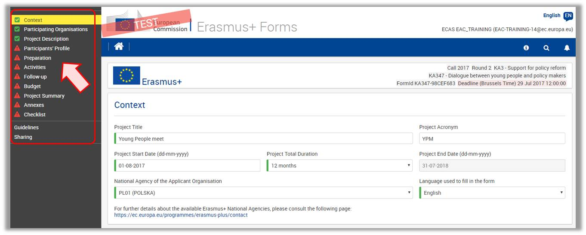

The Home button brings you back to the Web Application Forms main page.
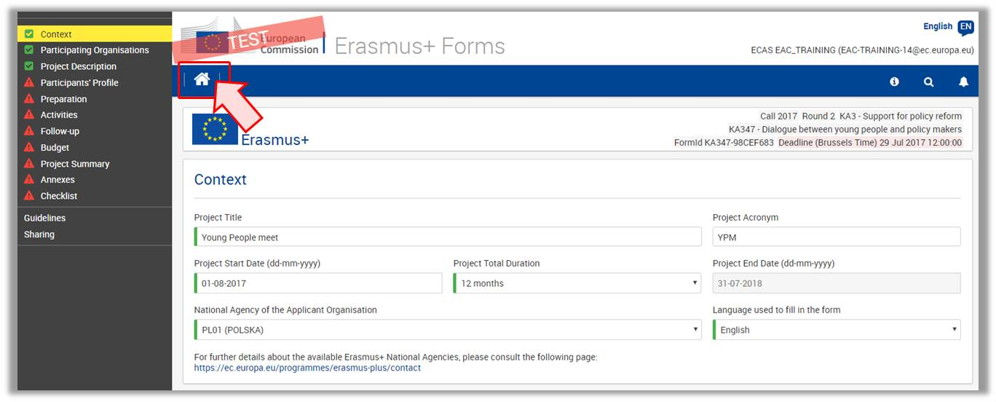

Menu button
Within various parts of the application, you have a MENU button available; for example in the Participating Organisations or Activities sections.
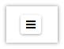
Depending on the section you are working on you have different options available to select from once you clicked it.
Here some examples:
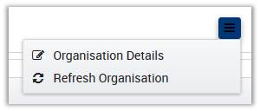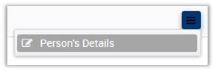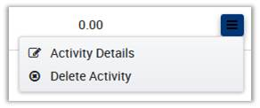

Underlined Links
You can access details of various elements of the application by clicking on hyperlinks. Those can be text or a dotted line.
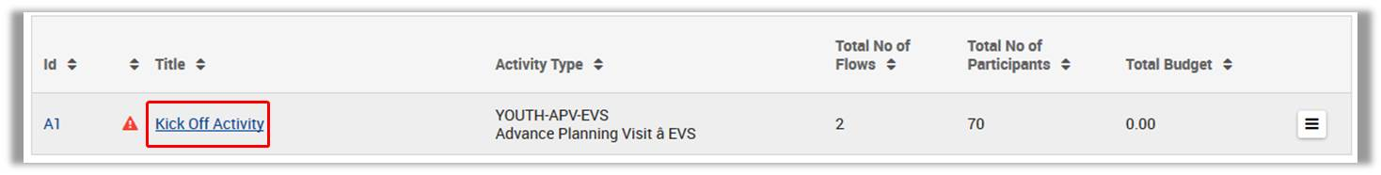
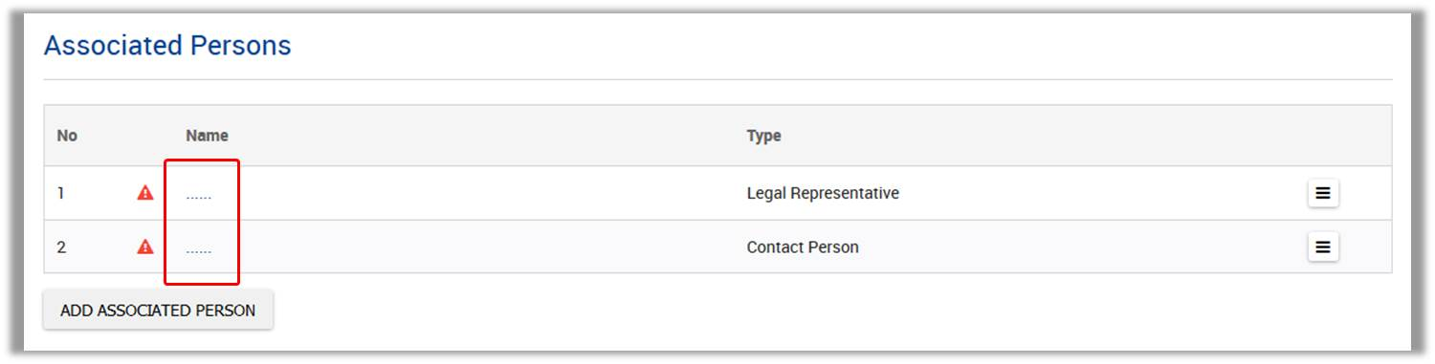

Auto Saving & Draft
The form is automatically saved every 2 seconds. The Saved (Local Time) information on the left hand side of the screen is updated accordingly.
After closing the form, you can access it again under the tab My Applications on the Web Application Forms homepage.
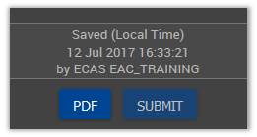

Help and Guidelines
Throughout the form it is possible to acquire more information about particular parts by positioning your mouse pointer over the question mark sign.

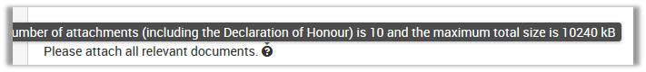
In the left hand side menu you also have a Guidelines option. Clicking on this menu item will open the Guidelines screen with useful information.
